Provide screenshot of hacked android device.
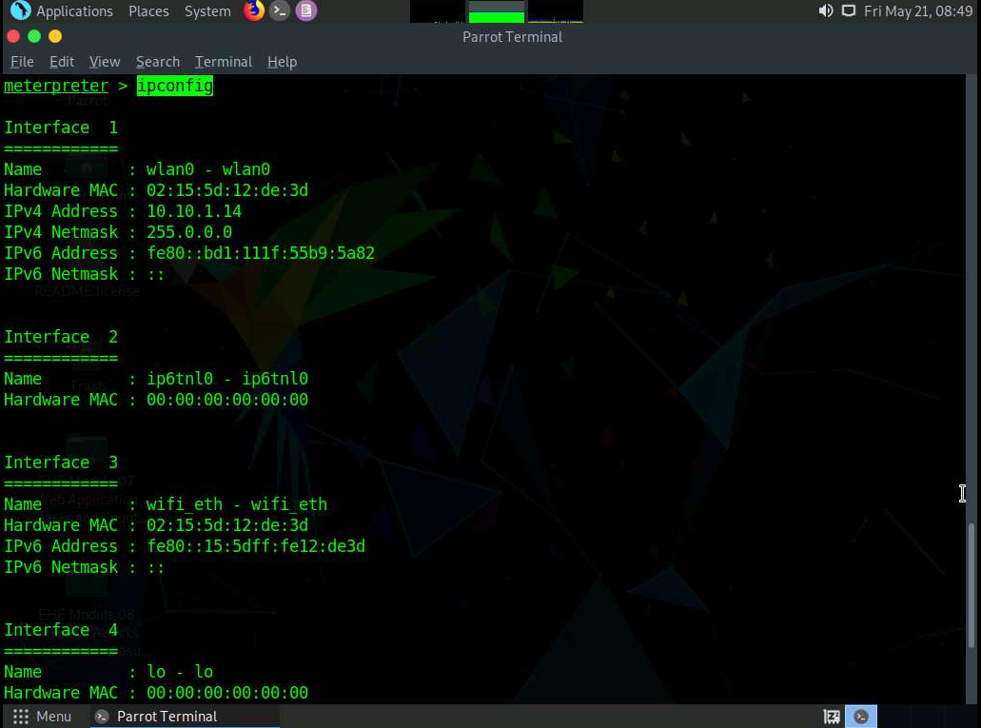
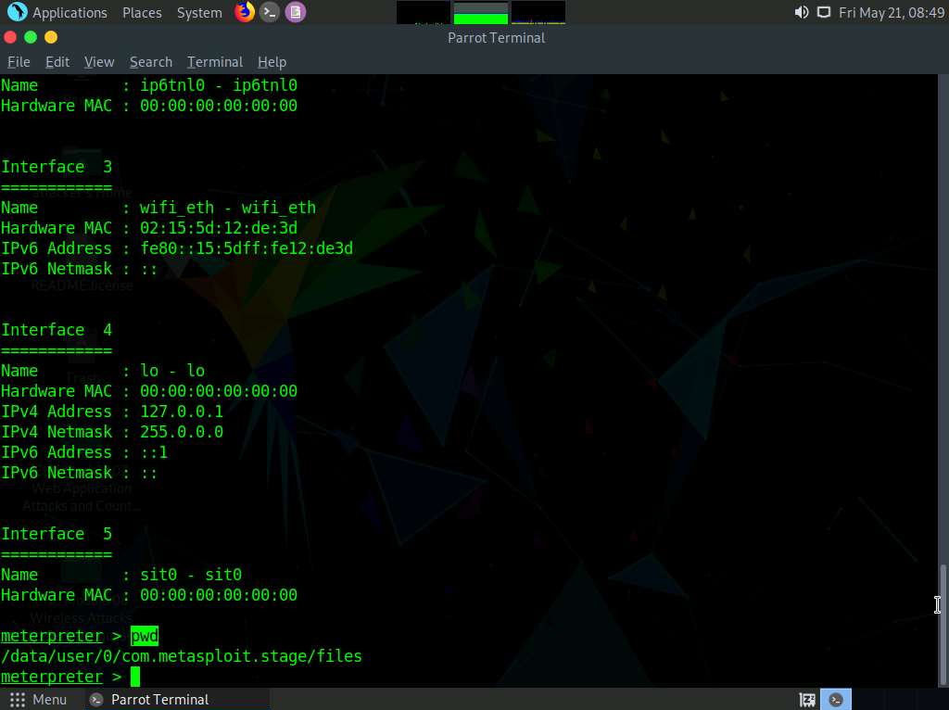

What could have been done to prevent this attack?
Don’t download the suspicious file and install the packet.

Provide screenshot of Malwarebytes installed and running
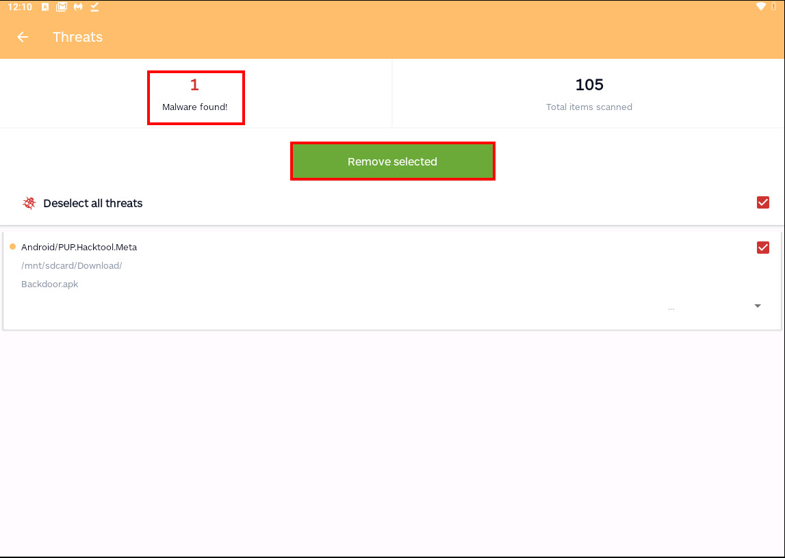
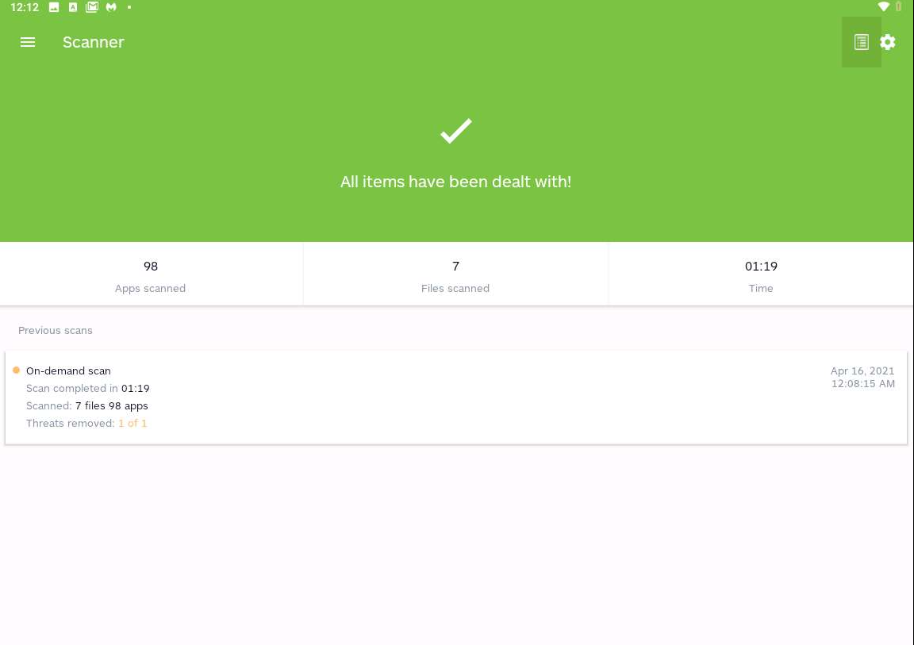
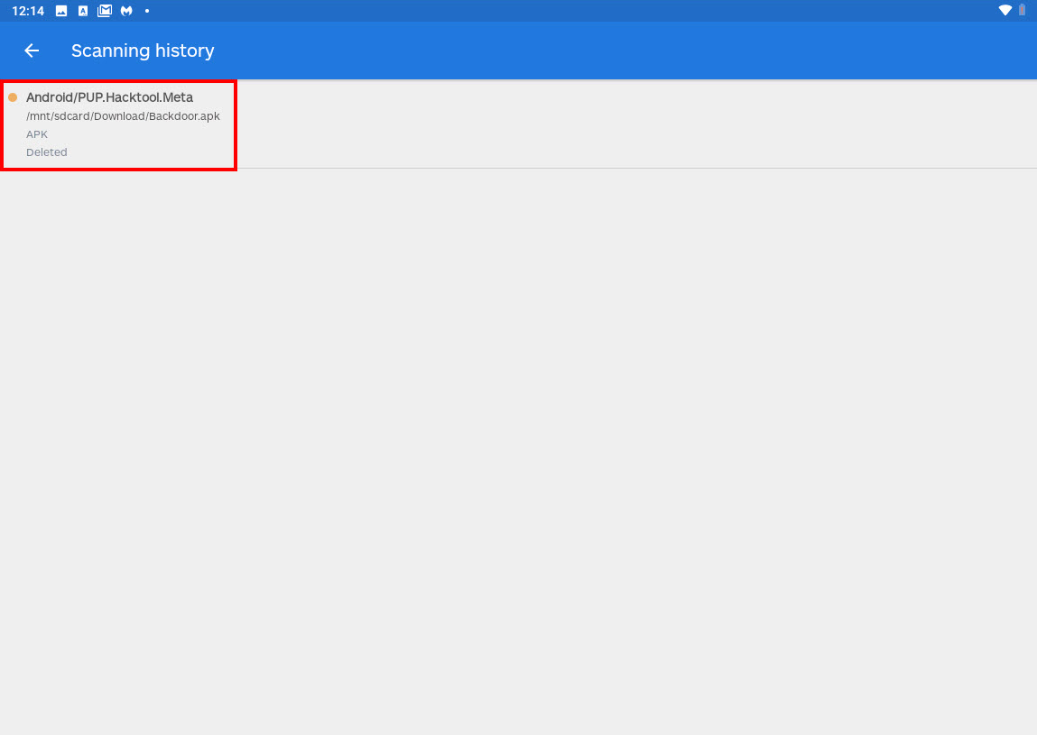
- What worked well in the lab?
Yes, I had no problem running the lab this time.
- What parts were troublesome?
I only have one trouble during this lab, was creating the backdoor.apk file on the website to download using the android device, I figure out that one of directory files was not created.
- Over all impression of the lab?
Was a great lab, very helpful in protect my own devices from attacks.

